

***FOUNDED MARCH 1971*** [***WWW.IRISHHISTORYROUNDTABLE.ORG***](http://WWW.IRISHHISTORYROUNDTABLE.ORG) ***September 2023***

***Vicksburg, Mississippi , and the Connecticut Irish Regiment***

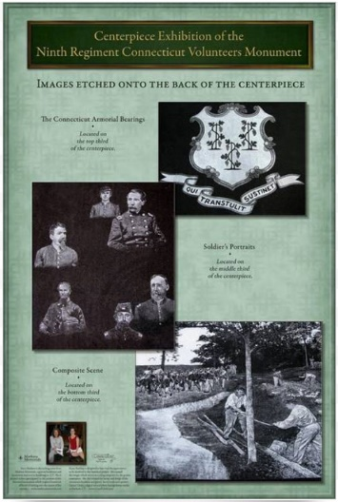

**For our Sept. 19th IHRTmeeting , we are pleased to welcome Bob Larkin, IHRT member and the strong force behind a national memorial for the CT Irish Civil War regiment . Bob updates us with the construction and approved placement of this monument , how its cost was established, and a few unconventional stories coming out of this national monument’s planning. There’ll be more details about the memorial’s 9th regiment gleaned from his recent 2022 Mississippi to Vicksburg tour.**

**Come hear this fascinating subject. The talk is free and open to the public. See you at 7:30pm. Knights of St. Patrick Hall, 1533 State St., New Haven.**

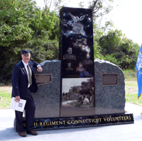**Bob Larkin is an active mover and shaker in the CT Irish community. He’s a member of the AOH, CTIAHS, Knights of Columbus, and the Civil War Round Table. Without his planning and enthusiasm, this monument would not exist. Here we see him in October, 2008, at the dedication ceremony. Bob, a Villanova graduate, worked for SNET and then the national fiber optics company of Lightnet before retiring.**

***UPCOMING EVENTS I****rish Book Club is reading Rememberings by S. O’Connor. Oct. 9 at 4pm. Additional literary talk by B. Saundrs. Contact: 203.288.9035.*

***Gaelic Mass:*** Sept. 17, Sun., 5pm. IACC, East Haven. Contact: Finbarr at 203.272.0118. Reception follows.

***Wreath Ceremony :*** Oct.28 , Sun., 10 am , Irish Civil War regiment memorial . City Point, New Haven. Tom Callinan‘s music . Reception to follow.